Contents
PART A - SYSTEM ANALYSIS AND REQUIREMENTS 2
1.1 Company Profile - Lekope FM 2
1.2 Current System Weaknesses 3
1.3 Stakeholder Identification 5
1.4 System Requirements 6
PART B - SYSTEM DESIGN AND TECHNOLOGY RECOMMENDATION 8
2.1 Data Flow Diagram (DFD) 8
Level 0 DFD - Context Diagram 8
Level 1 DFD - System Decomposition 9
2.2 Entity Relationship Diagram (ERD) 10
2.3 Technology Selection and Justification 12
2.4 Prototype Description 14
PART C - SECURITY, ETHICS AND IMPLEMENTATION 18
3.1 Security Threats and Controls 18
3.2 Ethical and Regulatory Considerations 20
3.3 Implementation Plan 21
PART D - FINANCIAL MODELLING AND DEMONSTRATION 22
4.1 Cost-Benefit Analysis 22
4.2 Dashboard Mock-Up 25
CONCLUSION 29

FINANCIAL INFORMATION SYSTEM (FIS) REPORT

PART A - SYSTEM ANALYSIS AND REQUIREMENTS

1.1 Company Profile - Lekope FM
Lekope FM is a rapidly growing media Small and Medium Enterprise (SME) based in Maseru, Lesotho. Initially established as a community radio station, the organisation has evolved into a diversified media company offering a wide range of communication and broadcasting services. These services include radio broadcasting, live television streaming through Lekope TV, online news publication, event coverage services, advertising sales, and newspaper production. The organisation currently employs between twenty and thirty staff members consisting of radio presenters, journalists, technical support personnel, sales representatives, accountants, and administrative staff.
The growth of Lekope FM has created increased demand for effective financial management and information processing. As the organisation continues to expand its operations and customer base, the volume of financial transactions has increased significantly. Revenue is generated from multiple streams including advertising airtime sales, sponsorship agreements, event partnerships, digital subscriptions, and media production services. Managing these diverse sources of revenue requires accurate, timely, and secure financial information.
Currently, Lekope FM relies on Microsoft Excel spreadsheets, QuickBooks accounting software, and manual paper-based processes to manage financial activities. While these tools were sufficient during the organisation's early stages, they are no longer capable of supporting the complexity associated with a growing media enterprise. Osrganisations experiencing rapid growth often outgrow their traditional accounting systems, resulting in inefficiencies, security risks, and reduced decision-making capabilities.
The implementation of a dedicated Financial Information System (FIS) is therefore necessary to improve financial management, strengthen internal controls, support regulatory compliance, and enhance strategic decision-making. The proposed system will integrate financial processes across the organisation and provide a centralised platform for transaction processing, reporting, budgeting, payroll management, and financial forecasting.
This report presents the analysis, design, implementation strategy, security considerations, and financial justification for the proposed Financial Information System. The report follows recognised Financial Information Systems methodologies and incorporates stakeholder analysis, Data Flow Diagrams (DFDs), Entity Relationship Diagrams (ERDs), security threat assessments, technology evaluation, and cost-benefit analysis.

1.2 Current System Weaknesses
An evaluation of the current financial management environment at Lekope FM reveals several weaknesses that negatively affect operational efficiency, data quality, and organisational performance. These weaknesses highlight the need for a more integrated and automated Financial Information System.
Inconsistent Financial Data
The organisation currently stores financial information across multiple Excel spreadsheets maintained by different departments. Because there is no centralised database, information is often duplicated and updated independently by different users. This creates version control problems where staff members may be working with outdated or conflicting data. As a result, financial reports generated from different sources may not reconcile accurately.
Inefficient Reporting Processes
Financial reporting at Lekope FM is largely manual. At the end of each month, staff members must collect data from various spreadsheets, invoices, receipts, and accounting records before preparing management reports. This process typically requires two to three working days and consumes valuable employee time. The delay prevents management from obtaining timely information regarding organisational performance.
Limited Forecasting and Planning Capabilities
The current system does not provide forecasting functionality. Management cannot accurately predict future revenue trends, cash flow requirements, or seasonal fluctuations in advertising income. Financial planning therefore relies heavily on assumptions rather than data-driven analysis. Without forecasting capabilities, the organisation may struggle to identify growth opportunities, manage financial risks, and allocate resources effectively.
Security Vulnerabilities
Financial spreadsheets are stored on shared computers and network drives with limited access restrictions. This means that employees who do not require access to financial information may still be able to view, modify, or delete sensitive records. Such practices violate the principle of least privilege, which states that users should only have access to the information necessary to perform their job responsibilities. The absence of strong access controls increases the risk of unauthorised disclosure, accidental modification, and intentional fraud.

Lack of Audit Trail Functionality
An effective Financial Information System should maintain a complete history of all transactions and modifications. However, the current system provides no automated mechanism for recording changes made to financial data. Consequently, management cannot determine who modified a record, what changes were made, or when the changes occurred. This lack of accountability weakens internal controls and complicates auditing activities.

Poor System Integration
The advertising sales process and financial accounting functions operate independently of one another. Advertising bookings are recorded separately from invoicing activities, resulting in delays between service delivery and invoice generation. These delays can negatively affect cash flow, increase debtor balances, and reduce customer satisfaction. The absence of integration also increases the likelihood of data entry errors and omitted transactions.

1.3 Stakeholder Identification
Stakeholder analysis is an important component of systems development because it ensures that the proposed solution meets the needs of all individuals and groups affected by the system. The proposed Financial Information System will serve a diverse range of stakeholders within and outside the organisation.
Chief Executive Officer (CEO)
The CEO is responsible for strategic decision-making and organisational leadership. The CEO requires access to high-level financial dashboards, profitability reports, revenue trends, and forecasting information. These reports will support strategic planning and enable informed business decisions.

Finance Manager
The Finance Manager is responsible for overseeing daily financial operations. This stakeholder requires detailed access to the general ledger, budget performance reports, cash flow statements, accounts receivable information and payroll data. Real-time access to financial information will improve financial control and reporting accuracy.

Sales and Advertising Team

The sales team generates revenue through advertising and sponsorship agreements. These users require access to customer accounts, invoice generation functions, payment tracking information, and alerts regarding overdue accounts. Integration between sales and finance functions will improve efficiency and reduce billing delays.
Employees and Radio Presenters
Employees require access to payroll information, payslips, tax deductions, and expense claim submissions. A self-service employee portal would improve convenience while reducing administrative workload.
External Auditors
External auditors require read-only access to verified financial records and audit logs. This access supports independent verification of financial information and assists with regulatory compliance.
IT Administrator
The IT Administrator is responsible for maintaining system security and availability. This stakeholder requires access to user management functions, security logs, backup status information, system performance metrics, and access control reports.
Lesotho Revenue Authority (LRA)
The LRA requires accurate tax reporting information. The proposed system will generate tax-compliant reports and support regulatory submissions, reducing the risk of penalties and compliance violations.
The identification of these stakeholders ensures that the proposed system addresses both operational and strategic information requirements across the organisation.

1.4 System Requirements
Functional Requirement
Functional requirements define the specific activities and processes that the Financial Information System must perform.
1.The system shall process and record all financial transactions including revenue, expenses, payroll transactions, journal entries, and invoices using double-entry accounting principles.
2. The system shall generate standard financial reports including Profit and Loss Statements, Balance Sheets, Trial Balances, Cash Flow Statements, and General Ledger Reports.
3.The system shall support budgeting and forecasting activities through analytical tools and graphical performance comparisons.
4. The system shall automatically generate invoices for advertising and sponsorship services and issue payment reminders for overdue accounts.
5. The system shall calculate employee salaries, tax deductions, allowances, and generate digital payslips.
6.The system shall implement role-based access control to restrict access according to organisational responsibilities.
7. The system shall maintain a complete audit trail that records all transactions, modifications, approvals, and login activities.
8. The system shall generate tax reports that comply with Lesotho Revenue Authority requirements.

Non-Functional Requirements
Performance
The system shall respond to user requests within three seconds under normal operating conditions and support up to fifty concurrent users.
Security
All sensitive information shall be encrypted using industry-standard encryption technologies including AES-256 for stored data and TLS 1.3 for data transmitted across networks.
Availability
The system shall maintain an uptime level of at least 99.5% to ensure continuous access to financial information.
Scalability
The architecture shall support organisational growth from approximately thirty employees to more than two hundred users without requiring major redesign.
Usability
The system interface shall be intuitive, user-friendly, and suitable for users with limited technical expertise. The design shall comply with recognised usability standards including ISO 9241.
The successful implementation of these requirements will ensure that the proposed Financial Information System effectively supports Lekope FM's operational, strategic, and regulatory objectives.

PART B - SYSTEM DESIGN AND TECHNOLOGY RECOMMENDATION

2.1 Data Flow Diagram (DFD)
A Data Flow Diagram (DFD) is a graphical representation used to illustrate how data moves through an information system. DFDs help analysts understand system processes, data stores, external entities, and the flow of information between them. The proposed Financial Information System for Lekope FM uses DFDs to demonstrate how financial data is captured, processed, stored, and reported.

Level 0 DFD - Context Diagram
The Level 0 DFD, also known as the Context Diagram, presents the entire Financial Information System as a single process. The purpose of this diagram is to define the system boundary and identify external entities that interact with the system.

The proposed Lekope FIS receives information from advertising clients, employees, management, external auditors, and the Lesotho Revenue Authority (LRA). Advertising clients submit payments and receive invoices, while employees submit expense claims and receive payroll information. Management receives financial reports and dashboards that support decision-making. External auditors access financial records and audit reports, while the LRA receives tax-related reports and submissions.

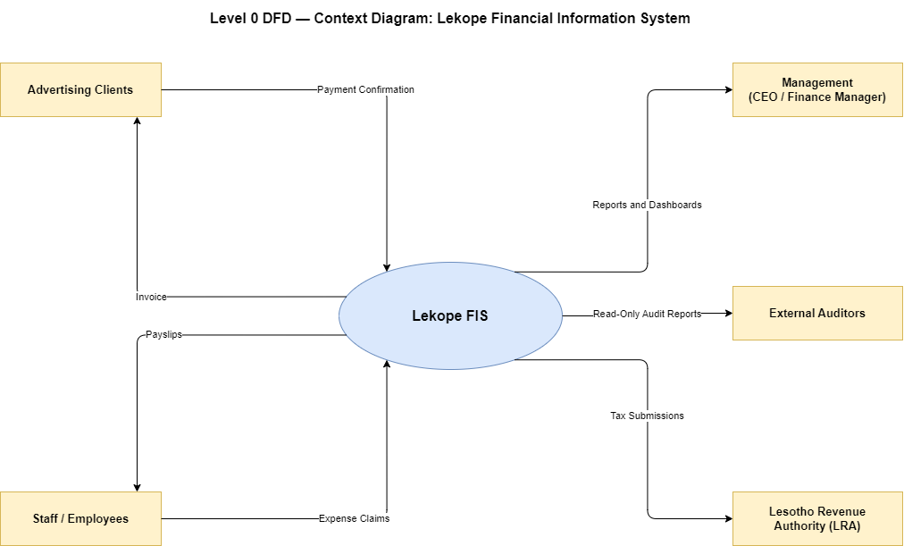
The Context Diagram demonstrates that all financial information flows through a centralised system before being processed and distributed to relevant stakeholders.

Level 1 DFD - System Decomposition
The Level 1 DFD breaks down the Financial Information System into its major functional processes. This level provides a more detailed view of how data is processed within the system.
The proposed system consists of five primary processes:
Manage Transactions: Responsible for recording revenue, expenses, and other financial transactions.
Generate Invoices: Creates and manages client invoices for advertising and sponsorship services.
Process Payroll: Calculates salaries, deductions, and employee payments.
Produce Reports: Generates financial statements, dashboards, and regulatory reports.
Manage User Access: Controls authentication, authorisation, and audit logging activities.
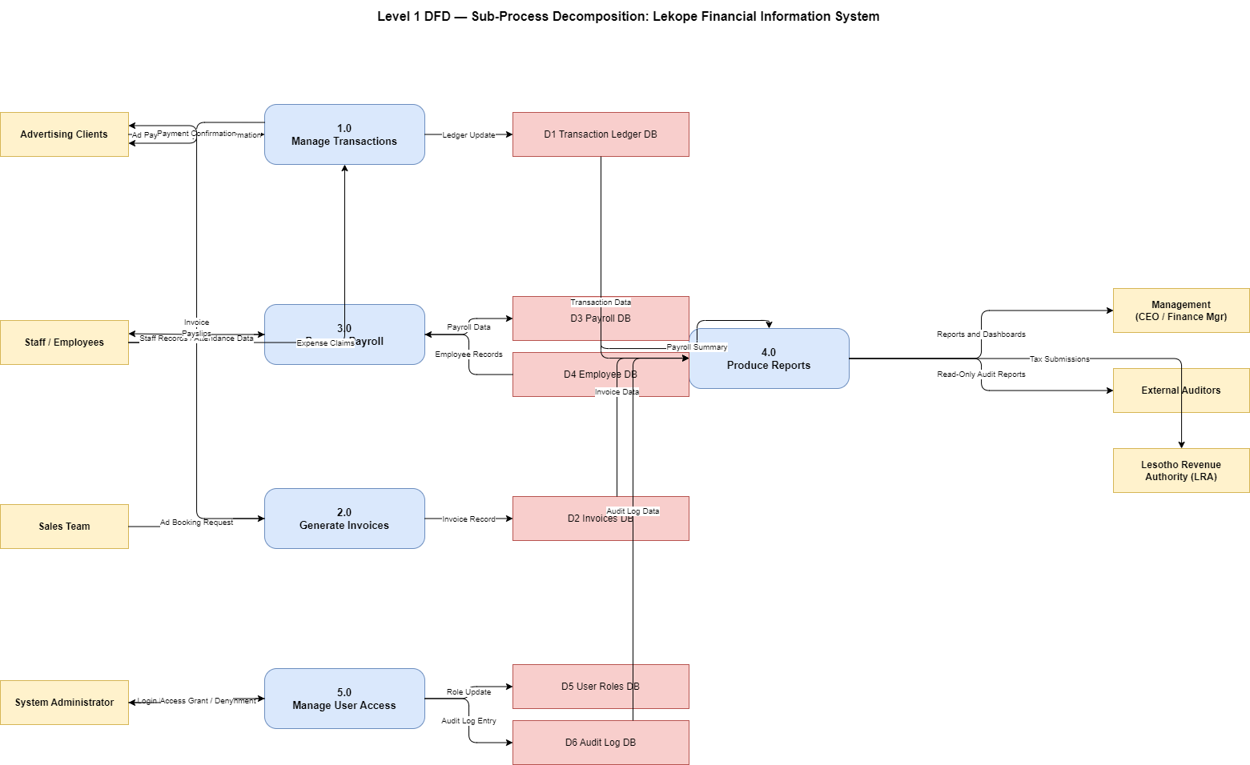

The Level 1 DFD provides a detailed understanding of how information moves between processes and data stores while maintaining consistency with the Context Diagram.

2.2 Entity Relationship Diagram (ERD)
An Entity Relationship Diagram (ERD) is used to model the structure of the database that will support the Financial Information System. The ERD identifies entities, attributes, primary keys, foreign keys, and relationships between records.

The proposed database contains eight primary entities:
USER - Stores system user information such as names, email addresses, passwords, and assigned roles.
ACCOUNT - Stores chart of accounts information including assets, liabilities, equity, revenue, and expense accounts.
TRANSACTION - Records all financial transactions processed by the system.
CLIENT - Stores information relating to advertising and sponsorship customers.
INVOICE - Maintains invoice records generated for clients.
EMPLOYEE - Stores employee information required for payroll processing.
AYSLIP - Records payroll calculations and employee payment details.
AUDIT-LOG - Maintains a record of all significant system activities and changes.

The relationships between these entities support the flow of financial information throughout the organisation. For example, one client may have many invoices, one employee may receive many payslips, and one user may create many transactions and audit records.
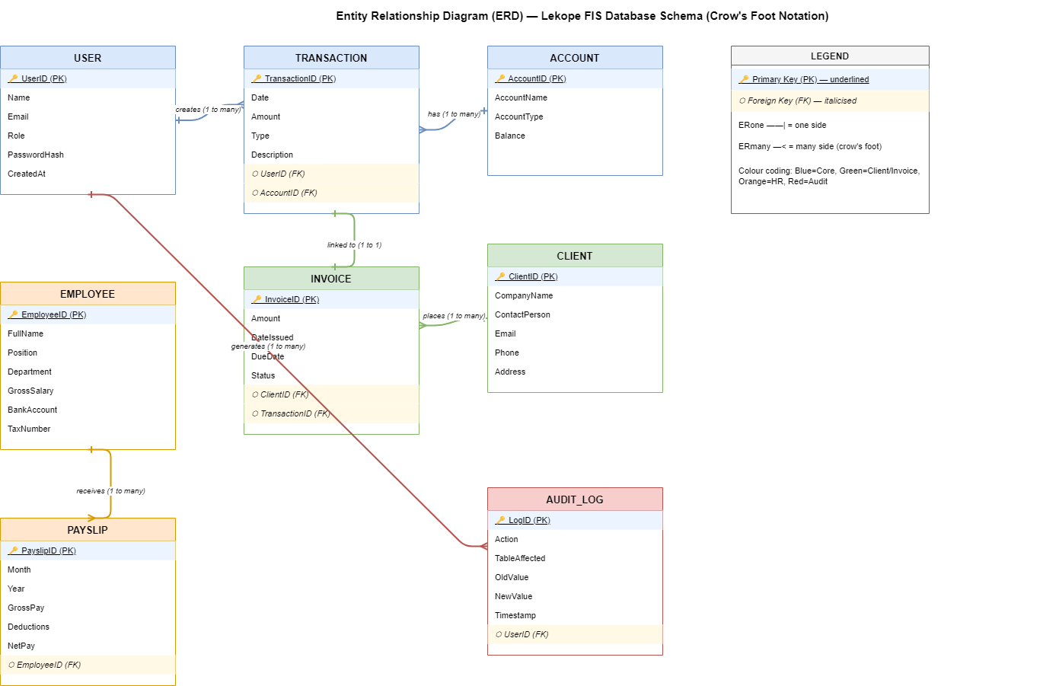
The ERD provides a blueprint for database implementation and ensures that financial data remains organised, accurate, and secure.

2.3 Technology Selection and Justification
The selection of appropriate technologies is critical to the success of the proposed Financial Information System. Technologies were selected based on cost, scalability, security, ease of maintenance, and suitability for a growing SME.
Frontend Technology - React.js
React.js was selected as the frontend framework because it supports the development of responsive and interactive user interfaces. React enables reusable components, making development faster and easier to maintain. The availability of charting libraries also makes React suitable for financial dashboards and reporting features.
Backend Technology - Node.js and Express
Node.js and Express were selected for the backend because they provide a lightweight and efficient platform for developing web-based applications. Using JavaScript across both frontend and backend simplifies development and improves maintainability.
Database Technology - MongoDB Atlas
MongoDB Atlas was selected as the database platform for the proposed Financial Information System because it provides a fully managed cloud database service with high availability, scalability, and automated backups. As a NoSQL document-oriented database, MongoDB stores data in flexible JSON-like documents, making it suitable for handling different types of financial and operational information within a growing media organisation.
MongoDB Atlas eliminates the need for maintaining physical database servers, reducing infrastructure costs and administrative overhead. The platform provides built-in security features including encryption at rest, network access controls, automated backup services, and role-based access management. These features support the security and compliance requirements of the proposed Financial Information System.
The cloud-based nature of MongoDB Atlas also allows the organisation to scale resources as transaction volumes increase. This ensures that the system can continue supporting organisational growth without major infrastructure upgrades.
Authentication Technology - JWT and bcrypt
JSON Web Tokens (JWT) will be used to manage user authentication, while bcrypt will be used to securely hash passwords. Together, these technologies provide secure and scalable user authentication.
Cloud Hosting - Microsoft Azure
Microsoft Azure was selected because it offers reliable cloud infrastructure, automated backups, disaster recovery capabilities, and strong security controls. Azure's data centres also provide high availability and support future organisational growth.
The selected technologies provide a secure, scalable, and cost-effective solution capable of supporting Lekope FM's current and future requirements.

2.4 Prototype Description
A prototype was developed to demonstrate the key features of the proposed Financial Information System and evaluate the usability of the user interface. The prototype was developed using React.js and focuses on the most important financial management functions.
The prototype includes a dashboard displaying total revenue, total expenses, and net profit figures. This dashboard provides management with a quick overview of organisational performance and supports informed decision-making.
A transaction entry form allows authorised users to capture income and expense transactions directly into the system. This feature supports accurate record-keeping and reduces reliance on manual spreadsheets.
The prototype also includes a graphical representation of monthly revenue and expenditure trends. The chart helps management analyse financial performance over time and identify important trends.
An invoice management section displays outstanding invoices and payment statuses. This feature assists the sales and finance departments in monitoring customer accounts and improving cash flow management.
AI Financial Assistant Integration
In addition to the core financial modules, the prototype includes an AI-powered financial assistant integrated into the dashboard. The AI assistant is designed to guide users when navigating the system by providing explanations of dashboard metrics, assisting with report interpretation and answering basic finance-related questions. For example, users can request explanations of revenue trends, expense summaries, outstanding invoices, and profitability indicators displayed on the dashboard. The AI assistant improves user experience by making financial information easier to understand, particularly for non-technical users, and supports faster decision-making by providing instant contextual guidance. The feature demonstrates how emerging Artificial Intelligence technologies can enhance the usability and effectiveness of modern Financial Information Systems.
DASHBOARD OVERVIEW

This screenshot demonstrates the dashboard module and supports Functional Requirements FR2 and FR3.

TRANSACTION ENTRY FORM
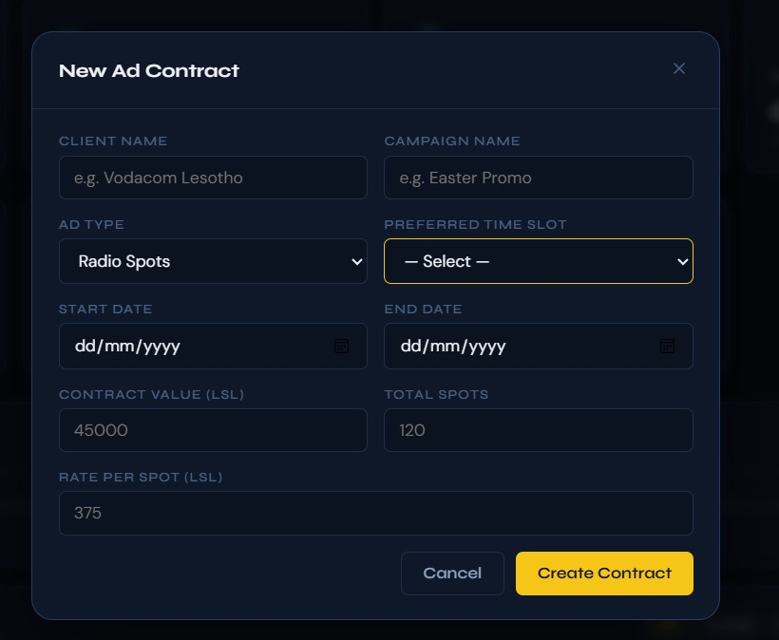
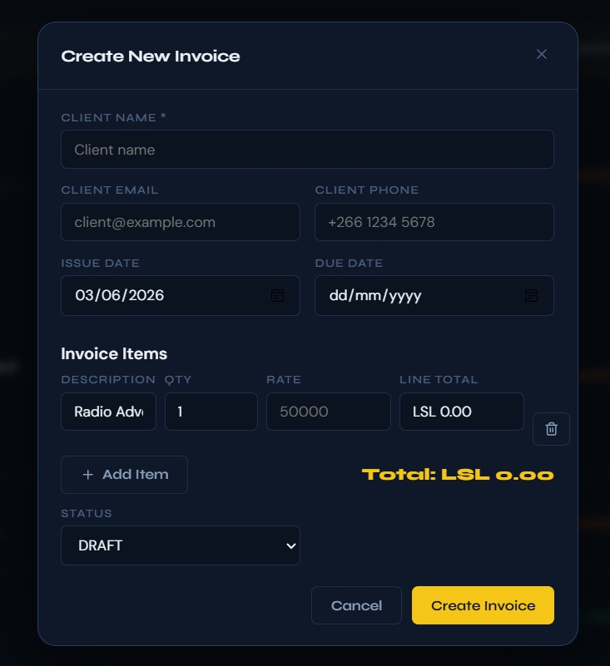
This screenshot demonstrates transaction recording functionality and supports Functional Requirement FR1.

REVENUE VS EXPENSES CHART
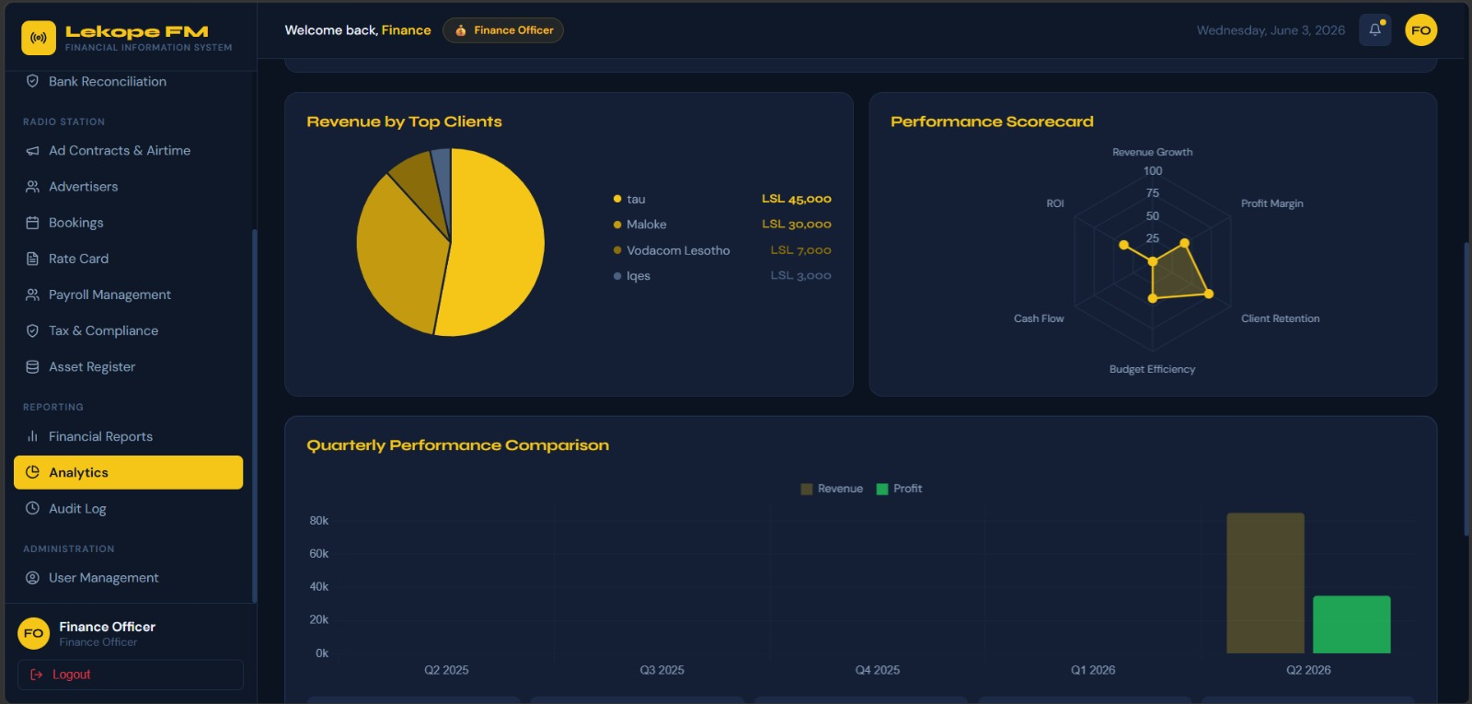
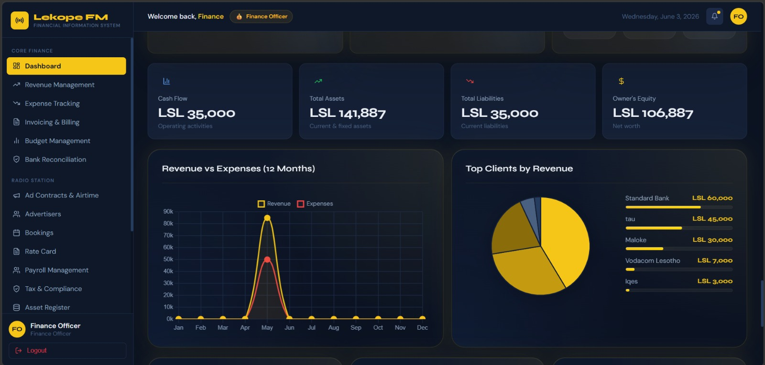
This screenshot demonstrates financial reporting and forecasting capabilities and supports Functional Requirement FR3.

OUTSTANDING INVOICES TABLE
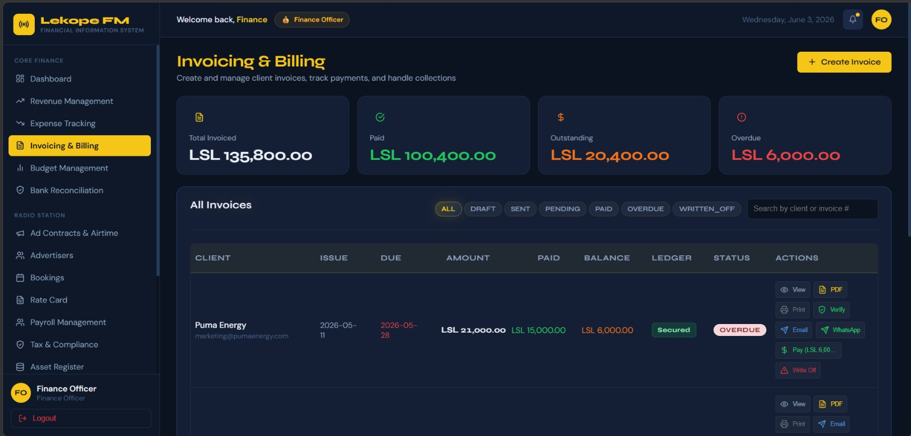
This screenshot demonstrates invoice management functionality and supports Functional Requirement FR4.

PART C - SECURITY, ETHICS AND IMPLEMENTATION

3.1 Security Threats and Controls
Information security is a critical requirement for any Financial Information System because financial records contain sensitive organisational and personal information. The proposed Lekope FM FIS must protect data from unauthorised access, manipulation, loss and cyber threats. Implementing effective security controls will help maintain confidentiality, integrity, and availability of financial information.
One of the primary threats facing the system is unauthorised access by users who do not have permission to view or modify financial records. If access controls are weak, sensitive information such as payroll records, revenue figures, and client payment details could be exposed. To address this risk, the system will implement Role-Based Access Control (RBAC), ensuring that users only access information relevant to their responsibilities.
Another significant threat is SQL injection and other database attacks. Although MongoDB Atlas is used as the database platform, improper handling of user input can still expose the application to security vulnerabilities. To reduce this risk, all user inputs will be validated and sanitised before being processed by the system. Secure coding practices will also be followed throughout development.
Phishing attacks remain a common method used by cybercriminals to steal user credentials. Employees may unknowingly disclose login details through fraudulent emails or websites. To reduce this risk, Multi-Factor Authentication (MFA) will be implemented and staff members will receive regular security awareness training.
Data transmitted between users and the system may also be vulnerable to interception if proper encryption is not used. The proposed system will therefore enforce HTTPS connections and utilise TLS encryption to protect information while it is being transmitted across networks.
The most important security controls implemented within the proposed system include:
• Role-Based Access Control (RBAC)
• Multi-Factor Authentication (MFA)
• Data encryption using HTTPS and TLS
• Automated cloud backups through MongoDB Atlas
• Audit logging of all critical activities
• Password hashing using bcrypt
Threat | Impact | Control Measure
Unauthorised Access | High | JWT authentication + role-based access control (RBAC)
Weak Passwords | High | bcrypt password hashing; enforce complexity rules
Data Loss | Critical | Automated daily backups to off-site cloud storage
Incorrect Financial Entries | Medium | Input validation; auto-calculated totals; duplicate-check
Insider Misuse | High | Audit logs; principle of least privilege per role
Malware / Ransomware | Critical | Endpoint security; sandboxed environment; daily backups
SQL / NoSQL Injection | High | Parameterised queries; input sanitisation via libraries

3.2 Ethical and Regulatory Considerations
The implementation of a Financial Information System introduces important ethical and legal responsibilities. Lekope FM will be required to manage financial and personal information in a manner that respects privacy rights, supports transparency, and complies with relevant laws and regulations.
Data Privacy
The system will store sensitive information including employee salaries, contact details, tax information, and client payment records. Because of the confidential nature of this data, appropriate safeguards must be implemented to prevent misuse and unauthorised disclosure. Access to personal information will be restricted to authorised users only, and information will be collected solely for legitimate business purposes.
The organisation must also comply with the Data Protection Act of Lesotho. This legislation requires organisations to process personal information fairly, securely, and only for authorised purposes. The proposed system supports these requirements through access controls, encryption mechanisms, and secure storage practices.

Financial Reporting Ethics
Financial information plays an important role in organisational decision-making and regulatory compliance. Management must therefore ensure that reports generated by the system accurately reflect the organisation's financial position. Users should not be able to manipulate financial records for personal benefit or to misrepresent organisational performance.
To support ethical financial reporting, all financial transactions will be recorded within an audit trail. Once approved, transactions will not be deleted but instead corrected through authorised adjustment procedures. This approach improves accountability and reduces opportunities for fraud.
Regulatory Compliance
The Financial Information System will assist Lekope FM in meeting its regulatory obligations. Tax reports generated by the system will support submissions to the Lesotho Revenue Authority, while financial reports will assist with compliance requirements applicable to media organisations and registered businesses operating within Lesotho.
Role-Based Access Control (RBAC) Matrix
Access to system modules is strictly controlled based on each user's role. The RBAC matrix below defines the permission level for each combination of role and module
Module | Station Manager | Finance Officer | Marketing Officer | Auditor
Dashboard | Full | Full | Limited | Read-only
Invoices | View | Full | View | Read-only
Revenue | View | Full | View | Read-only
Expenses | View | Full | None | Read-only
Payroll | View | Full | None | Read-only
Advertisers | View | View | Full | Read-only
Bookings | View | View | Full | Read-only
Tax | View | Full | None | Read-only
Assets | View | Full | None | Read-only
Bank Reconciliation | View | Full | None | Read-only
Reports & Analytics | Full | Full | Limited | Read-only
User Management | Full | None | None | None

3.3 Implementation Plan
The successful implementation of the proposed Financial Information System requires a structured approach that minimises disruption to normal business operations. A phased implementation strategy will allow the organisation to gradually introduce the system while ensuring that users receive adequate training and support.
The first phase will focus on planning and infrastructure preparation. During this stage, system requirements will be finalised, cloud services configured and the MongoDB Atlas database environment established. User accounts and security policies will also be created.
The second phase will involve system development. Core modules including transaction management, invoice processing, user authentication and financial reporting will be developed and tested. Regular reviews will be conducted to ensure that system requirements are being met.
During the third phase, advanced features such as payroll processing, dashboards, forecasting tools, and anomaly detection capabilities will be integrated into the system. Comprehensive testing will then be conducted to identify and resolve any issues.
The fourth phase will focus on security assessment and user training. Staff members will be trained on how to use the new system effectively, while security testing will be performed to ensure that vulnerabilities are identified and addressed before deployment.
The final phase will involve system deployment and monitoring. The new Financial Information System will operate alongside existing processes for a short period to ensure stability and accuracy. Once management is satisfied that the new system is functioning correctly, the legacy spreadsheet-based processes will be retired.

PART D - FINANCIAL MODELLING AND DEMONSTRATION

4.1 Cost-Benefit Analysis
Before implementing a new Financial Information System, it is important to determine whether the expected benefits justify the costs involved. A cost-benefit analysis provides a structured method for evaluating the financial feasibility of the proposed system by comparing implementation costs against expected organisational benefits over a specified period.
The proposed Financial Information System for Lekope FM requires investment in software development, cloud hosting services, staff training, security testing, and ongoing technical support. Although these costs may appear significant during the initial implementation period, they are expected to generate long-term financial and operational benefits.
The major implementation costs include:
• Software development and system customisation
• Cloud hosting and database services
• Staff training and user support
• Security audits and penetration testing
• Ongoing system administration and maintenance
The estimated costs for the first three years of operation are shown below.

Projected Costs
Cost Item | Year 1 (LSL) | Year 2 (LSL) | Year 3 (LSL)
Cloud hosting - Microsoft Azure (Africa region) | M18 000 | M14 000 | M14 000
Software development and customisation | M85 000 | M0 | M0
Staff training - 2-day workshop for 15 staff | M12 000 | M5 000 | M5 000
IT administration (part-time contractor) | M24 000 | M24 000 | M24 000
Annual security audit and penetration testing | M15 000 | M8 000 | M8 000
TOTAL COSTS | M154 000 | M51 000 | M51 000
While the implementation costs are highest during the first year, annual operating expenses decrease significantly after deployment because the system infrastructure and software development costs have already been incurred.

The proposed system is expected to generate several measurable benefits. One of the most significant benefits is the reduction in time spent preparing financial reports. Staff members currently spend several days each month collecting and consolidating information from multiple spreadsheets. Automating these processes will allow employees to focus on higher-value activities.
The system is also expected to reduce billing errors and improve invoice management. Faster invoice generation and automated payment reminders will improve cash flow and reduce revenue leakage. Improved compliance with tax regulations may also help the organisation avoid penalties associated with late or inaccurate submissions.

Additional benefits include:
• Improved financial accuracy
• Better decision-making through real-time reporting
• Enhanced regulatory compliance
• Increased operational efficiency
• Reduced risk of fraud and data loss
The estimated annual benefits are summarised below.

Benefit Source | Estimated Annual Value (LSL)
Time Savings from Reporting | M28 800
Reduced Billing Errors | M25 000
Compliance Savings | M20 000
Improved Cash Flow | M15 000
Total Annual Benefit | M88 800

Based on these estimates, the project is expected to recover its investment costs during the third year of operation. Although the first year reflects a negative return due to implementation expenses, subsequent years generate positive financial returns.

ROI Summary
Metric | Value
Year 1 Net Benefit (Benefits - Costs) | M88 800 - M154 000 = -M65 200 (investment year)
Year 2 Net Benefit | M88 800 - M51,000 = M37,800 (positive)
Cumulative Break-Even Point | Achieved in early Year 3
3-Year ROI | ≈ 18% - positive return justifies the investment

The analysis indicates that the proposed Financial Information System is financially viable and capable of generating both measurable and non-measurable benefits that support organisational growth.

4.2 Dashboard Mock-Up
The proposed Financial Information System includes a management dashboard designed to provide a clear and concise overview of organisational financial performance. Dashboards play an important role in modern Financial Information Systems because they transform large volumes of financial data into visual information that can be understood quickly by decision-makers.
The dashboard has been designed primarily for the Chief Executive Officer and Finance Manager. These stakeholders require timely access to key performance indicators that support operational monitoring and strategic planning.

The dashboard will include the following components:
AI Anomaly Detection Module
The proposed Financial Information System includes an AI-based anomaly detection module to help identify unusual financial transactions in real time. The module uses historical transaction data to train a machine learning model (Python + scikit-learn) that flags deviations from typical patterns, such as unusually high expenses or unexpected revenue entries.
Key points:
Advisory Only: The AI does not automatically block transactions; flagged items are reviewed by the Finance Manager to avoid errors from false positives.
Bias Mitigation: The model is retrained quarterly and audited for fairness to prevent systematic bias against specific departments or transaction types.
Integration: The AI module works asynchronously with the transaction database, enabling near real-time monitoring without affecting system performance.
Total Revenue
This component displays total revenue generated during the current reporting period. The information is obtained directly from financial transaction records and provides management with an immediate understanding of income performance.
Total Expenses
This widget displays the total expenses incurred during the selected reporting period. Monitoring expenses helps management control costs and identify areas where expenditure may require attention.
Net Profit
The net profit indicator calculates the difference between total revenue and total expenses. This metric provides a quick assessment of organisational profitability and overall financial health.
Revenue versus Expenses Chart
A bar chart compares monthly revenue and expenses over a twelve-month period. This visual representation enables management to identify trends, seasonal fluctuations and potential financial concerns.
Outstanding Invoices Table
The dashboard includes a table displaying unpaid invoices together with their due dates and payment status. This feature assists the finance and sales teams in managing accounts receivable and improving cash collection.
Cash Flow Projection Chart
A forecasting component provides an estimate of expected cash inflows and outflows over the next six months. This information supports budgeting and financial planning activities.
Revenue Source Breakdown
A pie chart displays the contribution of different revenue streams such as advertising sales, sponsorships, digital subscriptions, and event partnerships. Understanding revenue composition assists management in evaluating business performance and identifying growth opportunities.

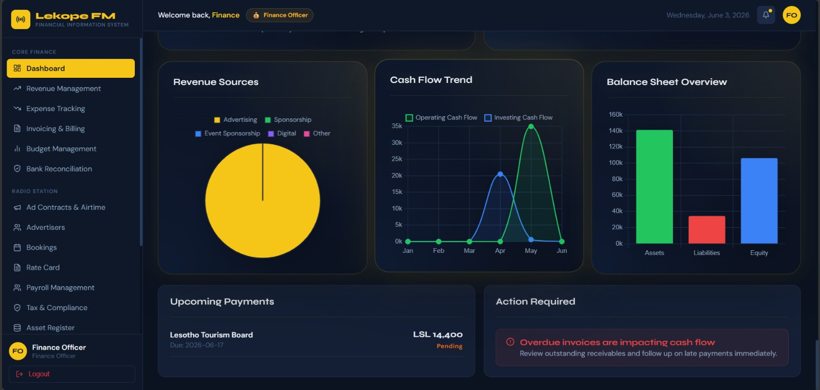
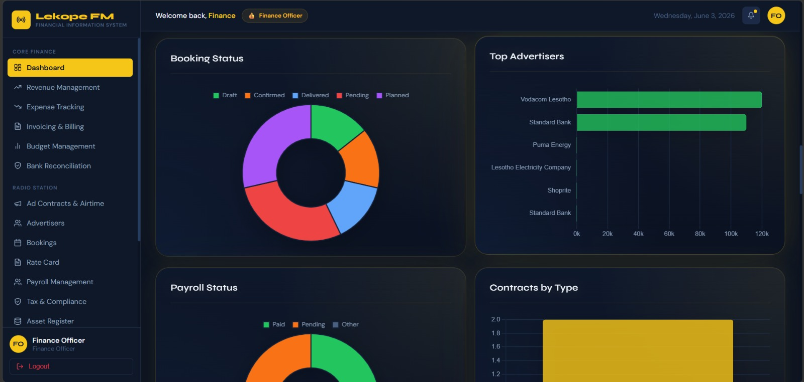
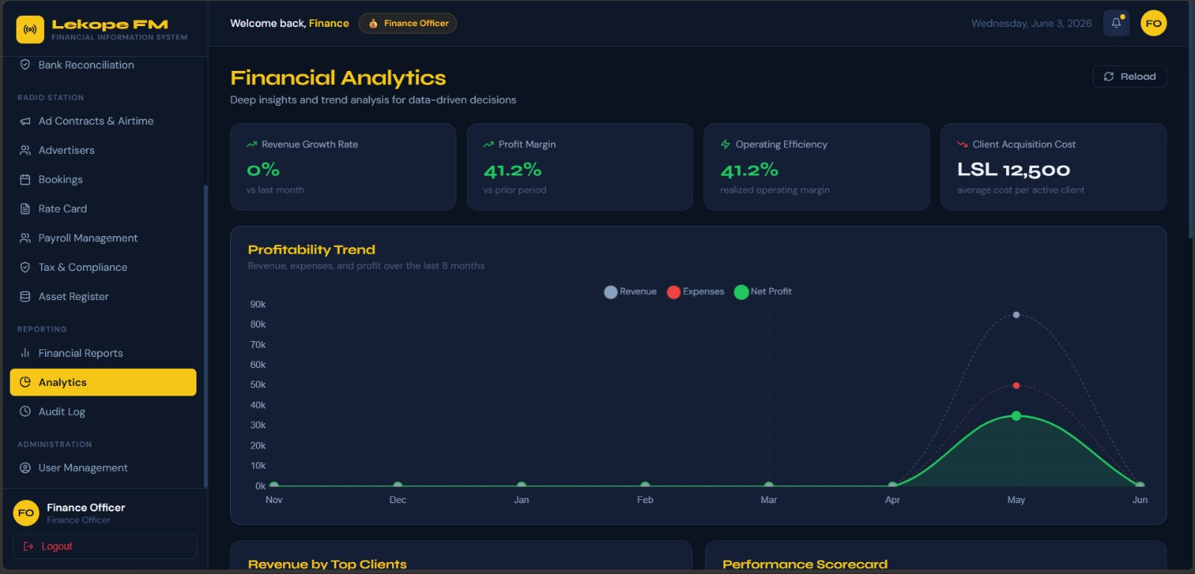
The dashboard design supports the information needs identified during stakeholder analysis. Senior management receives high-level financial summaries, while finance personnel can access more detailed operational information when required. The use of charts, tables and performance indicators improves information presentation and enables faster decision-making.
Overall, the proposed dashboard enhances the effectiveness of the Financial Information System by providing real-time visibility into key financial metrics and organisational performance.

CONCLUSION
The purpose of this report was to analyse, design and propose a Financial Information System (FIS) for Lekope FM, a growing media organisation in Lesotho. The analysis revealed several weaknesses in the current financial management approach, including reliance on spreadsheets, delayed reporting, limited forecasting capabilities, inadequate security controls and a lack of system integration. These challenges highlight the need for a more efficient and secure financial management solution.
The proposed Financial Information System addresses these issues by introducing automated transaction processing, invoice management, payroll processing, financial reporting and role-based access control. The system design incorporates modern technologies such as React, Node.js, MongoDB Atlas, and cloud-based services to provide a scalable, reliable, and user-friendly platform. Security measures including encryption, multi-factor authentication, audit logging, and automated backups have been recommended to protect sensitive financial information and support regulatory compliance.
The report also considered ethical and legal requirements related to data privacy, financial reporting integrity, and the responsible use of emerging technologies. A phased implementation plan was proposed to minimise operational disruption and ensure successful adoption by users. Furthermore, the cost-benefit analysis demonstrated that although the project requires significant initial investment, the expected operational efficiencies, improved reporting accuracy, and enhanced financial control justify the expenditure, with a positive return on investment projected within three years.

